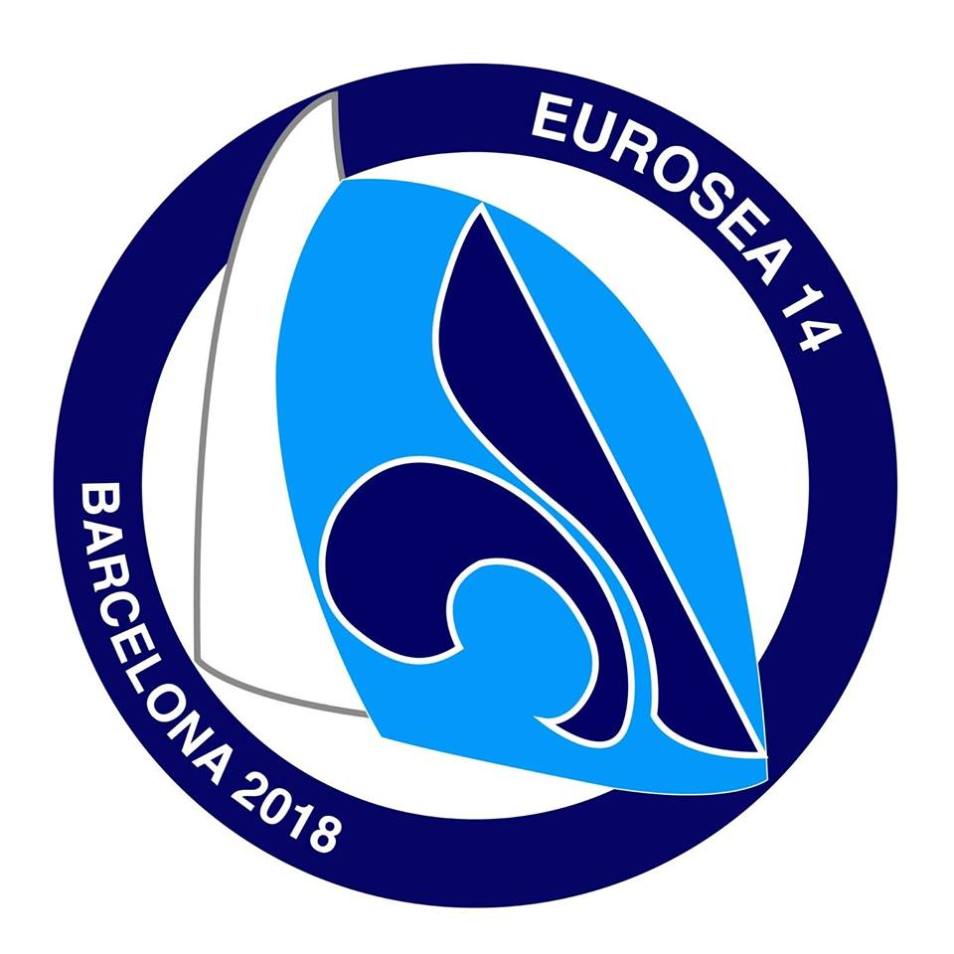
Application Form

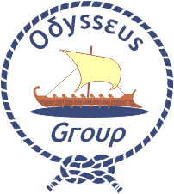
Eurosea 14

Barcelona, Spain | 5-9 September 2018

Please complete this form in CAPITAL LETTERS and return a scanned copy by 10 June 2018 to the World Scout Bureau Europe Support Centre, Geneva, by email: europe@scout.org

First Name and Family Name |  |  | Gender  Female  Male  Other 
Date and place of birth |  | Nationality
E-mail | Mobile Telephone |  | Fax
Association (Acronym, Full Name and Country)

Position in the Association

Please indicate the category that best describes your English
English Very Good  Good  Can Manage  Poor  None 

Do you have any dietary or other special requirements? Please specify

Have you ever participated in a European event?  Yes  No  |  | Do you need an official invitation to obtain a visa?  Yes  No 
Date & Name and Signature of the International Commissioner

For those needing a visa
Passport number |  | Nationality
Date of issue | Place of issue |  | Date of expiry
Address

I agree that any photos, taken at the event, can be used and published for Scouting purposes only.
The event will be held in English, participants should be able to communicate in English.

