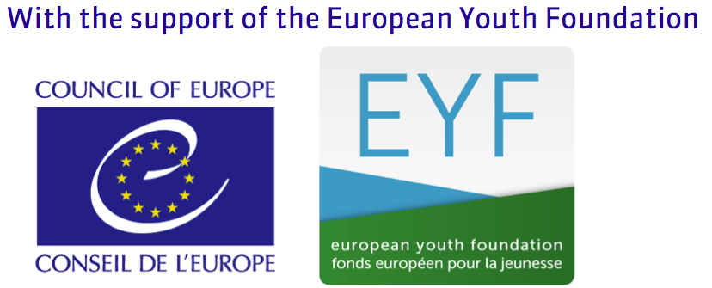
Regional Circular 9 2017 Annex 1

Application Form

Scouting for Peace

“Building the Open Spiritual Development Network (Spiriteco)”

Brussels, Belgium

9 – 11 June 2017

NOTE: Participants should arrive on Friday, 9 June 2017 in the morning (latest beginning of afternoon) and depart SUNDAY, 11 JUNE 2017 after 14:00

Please complete this form in capital letters and return by 22 MAY 2017 to
European Regional Office, Rue Henri Christiné 5, Box 327, CH - 1211 Geneva 4, Switzerland
Tel: (+41.22) 705 11 00 Fax: (+41.22) 705 11 09 e-mail: europe@scout.org

First name and family name |  |  | Gender  Male  Female  Other
Date and place of birth |  | Nationality
E-mail | Telephone |  | Fax
Association

Position in the Association

Please indicate the category that best describes your English
English Very Good  Good  Can Manage  Poor  None
Which other languages do you speak (include mother tongue)

Do you have any dietary or allergy requirement? Please specify
Do you have any special need, which would require specific assistance? Please specify
Have you ever participated in a European event?  Yes  No  |  | Do you need an official invitation to obtain a visa?  Yes  No 
Date and Signature of the International Commissioner

(…)

For those needing a letter in support of a visa application:

Passport number |  | Nationality
Date of issue | Place of issue |  | Date of expiry
Address

