Mandate

I, the undersigned,

[forename and surname of the legal representative of the partner organisation signing this mandate],

representing,

[official name]
[official legal status or form]
[official registration No]
[full official address]
[VAT number],

hereinafter referred to as "the partner organisation" or "my organisation",

for the purposes of participating in the project “Speak out for EUth” under the Erasmus+ programme (hereinafter referred to as "the project")
hereby:
1. Mandate

The Malta Girl Guides Association (MGG)
Non-profit organisation
VO/0222
49 Capuchins Street, FRN 1052, Malta
represented by Marjoe Abela, Chief Commissioner of The Malta Girl Guides Association
(hereinafter referred to as "the coordinator”)

To submit in my name and on behalf of my organisation the project application for funding within the Erasmus+ programme to the European Union Programmes Agency (EUPA) in Malta
hereinafter referred to as "the National Agency”

In case the project is granted by the National Agency, to sign in my name and on behalf of my organisation the grant agreement and its possible subsequent amendments with the National Agency.

2. Mandate the coordinator to act on behalf of my organisation in compliance with the grant agreement.

I hereby confirm that I accept all terms and conditions of the grant agreement and, in particular, all provisions affecting the coordinator and the other beneficiaries. In particular, I acknowledge that, by virtue of this mandate, the coordinator alone is entitled to receive funds from the National Agency and distribute the amounts corresponding to my organisation's participation in the project.

I certify that the information related to my organisation contained in this application is correct and that my organisation has not received/applied for any other EU funding to carry out the activity which is the subject of this project application.

I hereby accept that my organisation will do everything in its power to help the coordinator fulfil its obligations under the grant agreement, and in particular, to provide to the coordinator, on its request, documents or information may be required in relation to the grant agreement.

I hereby declare that the organisation I represent is not in any of the situations of exclusion set out in the project application and that it has the operational and financial capacity to complete the proposed action or work programme as set out in the project application.

I hereby declare to agree on behalf of my organisation that the provisions of the grant agreement shall take precedence over any other agreement between my organisation and the coordinator that may have an effect on the implementation of the grant agreement, including this mandate.

This mandate shall be annexed to the project application and shall form an integral part of the grant agreement in case the project is selected for funding.

SIGNATURE
[forename, surname, function of the legal representative of the mandating partner organisation]

[signature]
Done at [place], [date]
Marjoe Abela, Chief Commissioner
The Malta Girl Guides Association (MGG)
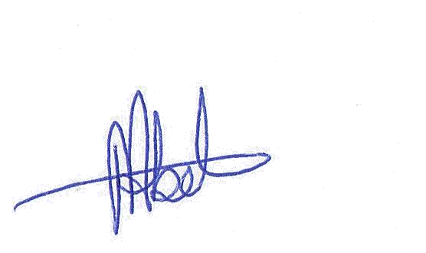
Done at Malta, 21.03.17

