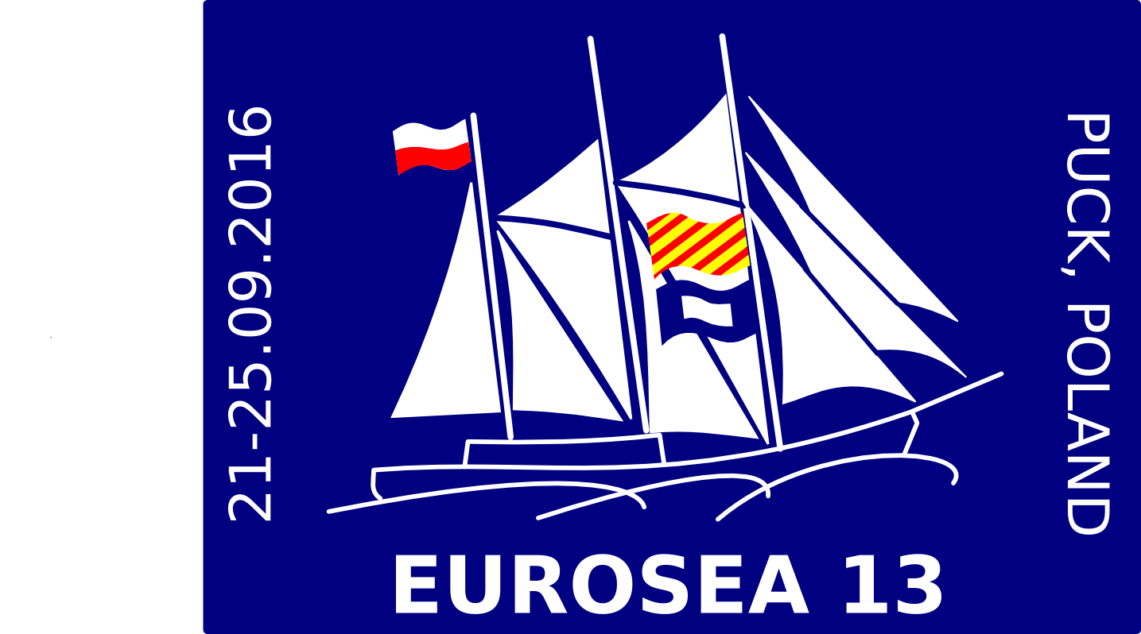
Application Form

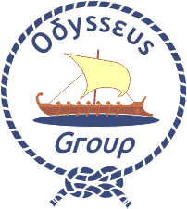
Eurosea 13

Puck, Poland, 21 - 25 September 2016

Please complete this form in CAPITAL LETTERS and return it by 15 May 2016 to:
European Scout Office, rue Henri Christiné 5, case postale 327, CH - 1211 Geneva 4, Switzerland
Tel: (+41.22) 705 11 00 e-mail: europe@scout.org

First name and family name |  |  | Gender  Male  Female 
Date and place of birth |  | Nationality
E-mail | Telephone |  | Fax
Association (Acronym, Full Name and Country)

Position in the Association

Please indicate the category that best describes your English
English Very Good  Good  Can Manage  Poor  None 

Do you have any dietary or other special requirements? Please specify

Have you ever participated in a European event?  Yes  No  |  | Do you need an official invitation to obtain a visa?  Yes  No 
Date and Signature of the International Commissioner

For those needing a visa
Passport number |  | Nationality
Date of issue | Place of issue |  | Date of expiry
Address

I agree that any photos, taken at the event, can be used and published for Scouting purposes only.
The event will be held in English, participants should be able to communicate in English.

