MANDATE TEMPLATE
Before using the mandate template please read this information carefully

A mandate is a bilateral agreement between the coordinating organisation and each partner organisation taking part in an Erasmus+ project by which the partner organisation authorizes the coordinating organisation to act on its behalf in matters related to the project implementation.

As regards the Erasmus+ actions managed by National Agencies (see Erasmus+ Programme Guide), a mandate must be provided:
- For Key Action 1 – Learning Mobility of Individuals:
  - by all partner organisations for mobility actions in the youth field;
  - by the organisations that are members of a national consortium in the fields of higher education, school education, vocational education and training, and adult education.
- For Key Action 2 – Strategic Partnerships:
  - By all partner organisations, except for:
    - partner organisations in projects involving schools only
- For Key Action 3 – Structured Dialogue in the youth field:
  - By all partner organisations

As indicated in the Erasmus+ Programme Guide, grant agreement models will be made available on the Commission's website as soon as possible.

Mandate

I, the undersigned,

[forename and surname of the legal representative of the partner organisation signing this mandate],

representing,

[full official name of partner organisation] [ACRONYM]
[official legal status or form]
[official registration No]
[full official address]
[VAT number],

hereinafter referred to as "the partner organisation" or "my organisation",

for the purposes of participating in the project Scout and Guide Academy under the Erasmus+ programme (hereinafter referred to as "the project")
hereby:
1. Mandate

CYPRUS SCOUTS ASSOCIATION (CSA)
National Scout Association
Government Houses Complex, House No. 48
P.O.Box 24544, 1301 Nicosia, CYPRUS
VAT number: 90000392X,
represented by Marios C. Christou – Chief Commissioner
(hereinafter referred to as "the coordinator”)

To submit in my name and on behalf of my organisation the project application for funding within the Erasmus+ programme to Youth Board of Cyprus in Cyprus
hereinafter referred to as "the National Agency”

In case the project is granted by the National Agency, to sign in my name and on behalf of my organisation the grant agreement and its possible subsequent amendments with the National Agency.

2. Mandate the coordinator to act on behalf of my organisation in compliance with the grant agreement.

I hereby confirm that I accept all terms and conditions of the grant agreement and, in particular, all provisions affecting the coordinator and the other beneficiaries. In particular, I acknowledge that, by virtue of this mandate, the coordinator alone is entitled to receive funds from the National Agency and distribute the amounts corresponding to my organisation's participation in the project.

I certify that the information related to my organisation contained in this application is correct and that my organisation has not received/applied for any other EU funding to carry out the activity which is the subject of this project application.

I hereby accept that my organisation will do everything in its power to help the coordinator fulfil its obligations under the grant agreement, and in particular, to provide to the coordinator, on its request, documents or information may be required in relation to the grant agreement.

I hereby declare that the organisation I represent is not in any of the situations of exclusion set out in the project application and that it has the operational and financial capacity to complete the proposed action or work programme as set out in the project application.

I hereby declare to agree on behalf of my organisation that the provisions of the grant agreement shall take precedence over any other agreement between my organisation and the coordinator that may have an effect on the implementation of the grant agreement, including this mandate.

This mandate shall be annexed to the [project application/grant agreement] and shall form an integral part of the grant agreement in case the project is selected for funding.

SIGNATURE

[forename, surname, function of the legal representative of the mandating partner organisation]

[signature]

Done at [place], [date]
Marios C. Christou

CYPRUS SCOUTS ASSOCIATION (CSA)

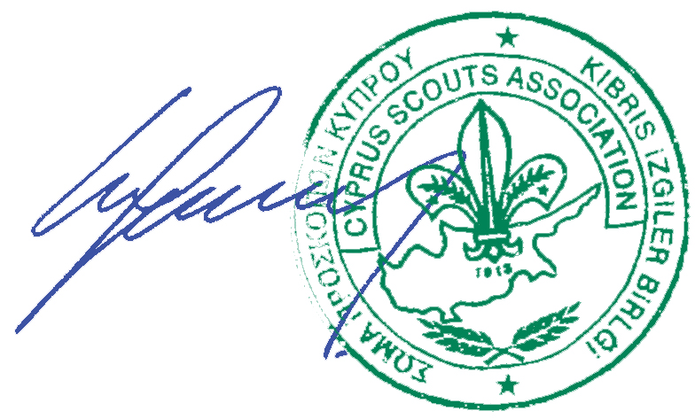
Done at Nicosia, 12th January 2016

In duplicate in English

One original version of this Annex to be included for each partner organisation except for the coordinator.
To be deleted or filled in according to the "Legal Entity" form
To be deleted or filled in according to the "Legal Entity" form
Choose as appropriate depending on when the mandate is submitted

