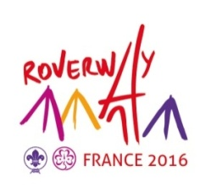
REGISTRATION FORM

Rover/Ranger Reps

Country

Association

1rst Rove/Ranger Reps:  First name and name:  Date of birth :  Gender :  Phone :  Email :  Skype  Social media (Facebook, Twitter, Google+)  Address : |  Male  Female
2d Rover/Ranger Reps :  First name and name:  Date of birth :  Gender :  Phone :  Email :  Skype  Social media (Facebook, Twitter, Google+)  Address : |  Male  Female

Is the person able to participate in the Rover/Ranger Reps meeting in Paris, 28-30 November 2014? :
 YES  NO

Date and signature of the International Commissioner.

Please fill this form in and send it back before 15 October 2014 to roversreps@roverway2016.org

Association Roverway 2016 - 65, Rue de la Glacière 75013 PARIS  : +33.1.47.07.89.47

