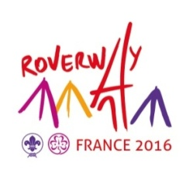
REGISTRATION FORM

Rovers Reps

Country

Organisation

First name and name

Function in the association

Date of birth

sex |  |  Male  Female
Phone : |  |  | Email
Adress

Is the person able to participate in the Rovers Reps meeting in Paris 28-30th of November 2014? :
 YES  NO

Date and signature of the International Commissioner.

Please fill this form in block letters and send it back before September 30th, 2014 to info@roverway2016.org

Association Roverway 2016 - 65, Rue de la Glacière 75013 PARIS  : 01.47.07.89.47

