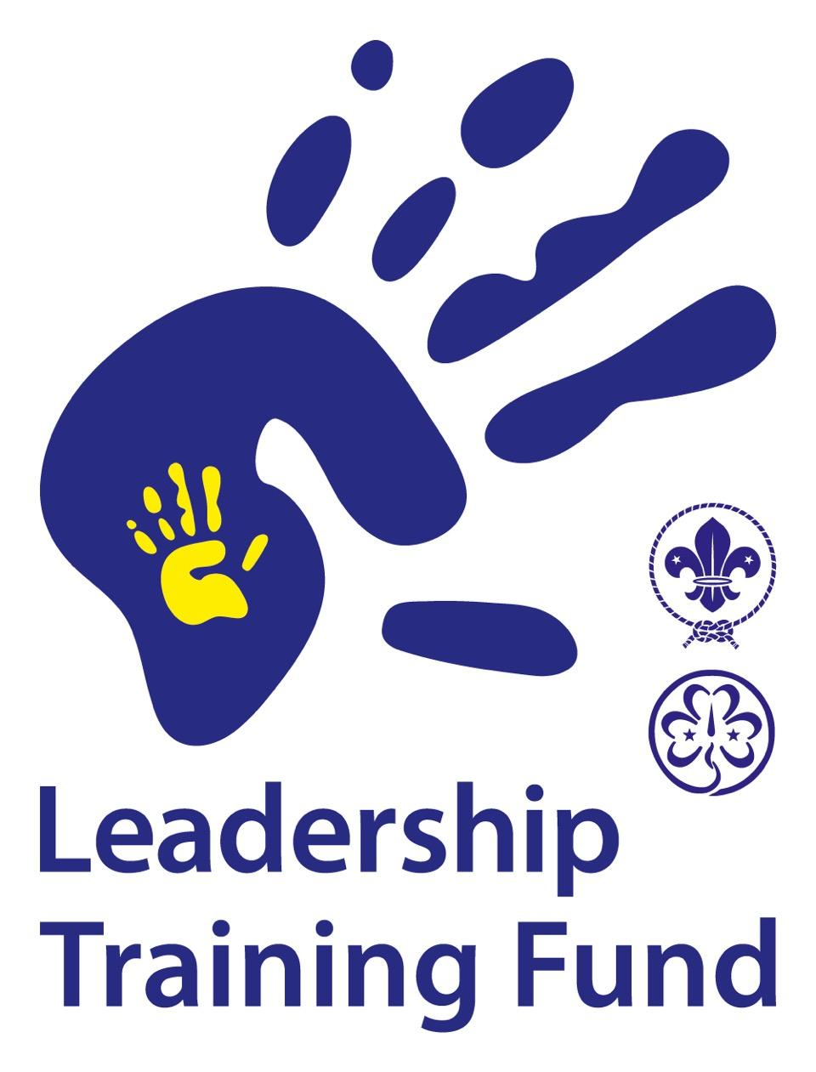
LTF Reporting Standards
and Checklist

Reporting Standards
- Report is received within 2 months after the completion of the project and before final installment.
- Attach a maximum of 5 pictures free for publication.
- The project report includes an overview of the activities completed and the impact the project had. Please adhere to a maximum of 700 words.
- The financial report is important to the LTF. Therefore, we expect a document (word or excel) of 2 pages.
- Please include copies of receipts for expenses incurred, as these fall under the auditing process of the European Scout Foundation which follow Swiss Law.

Checklist
When submitting your report please insure you complete the following requirements, failing to do so will result in rejection of the final report and will be returned for improvement. (Remember, the final installment will only take place once the final report is accepted.)

- Project report
- Financial report
- Maximum of 5 photos
- Copy of receipts
- Received within 2 months

