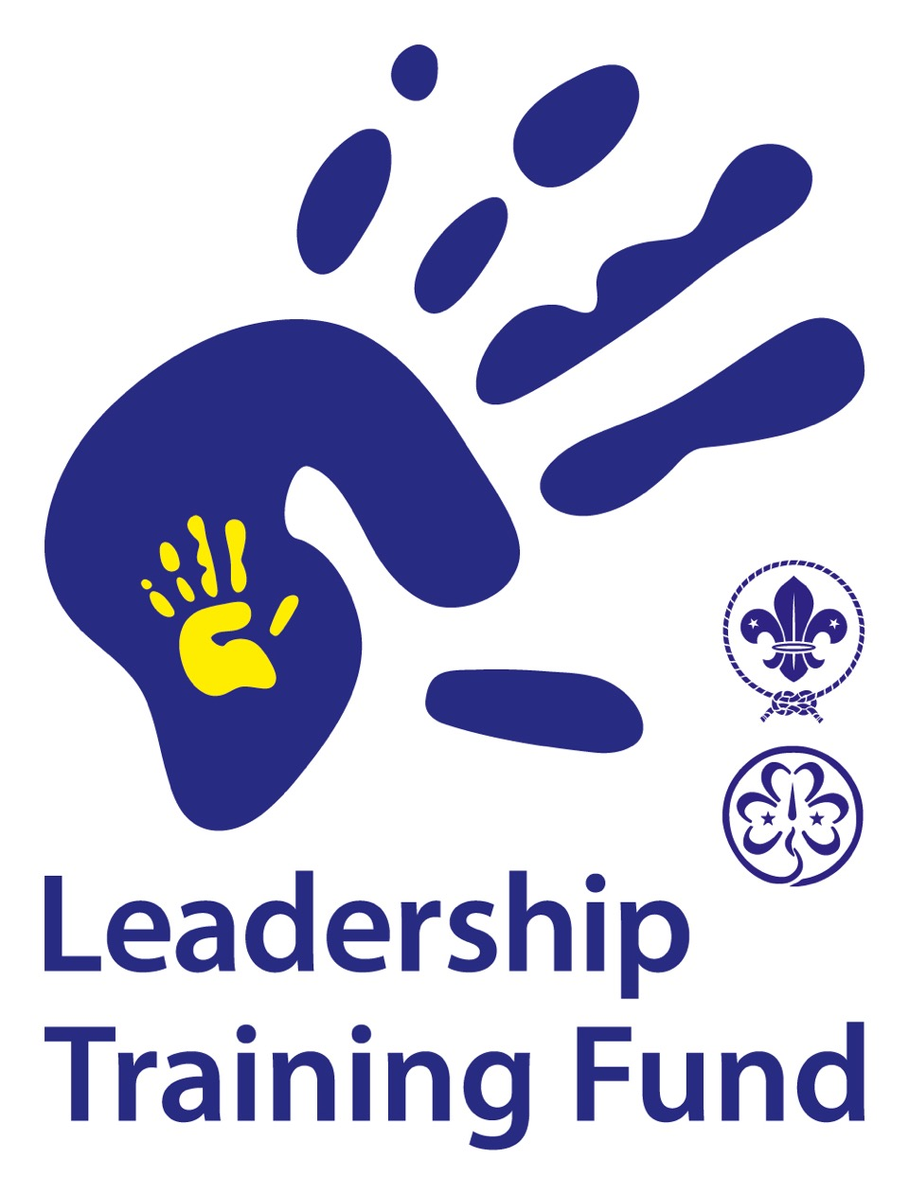
Application Form
Remember the following:
- This application form is submitted 3 months before the start of the project.
- There is a maximum number of words indicated.

Project Title:

Applicant association:
Name of association | Country:
Association contact and project leader: | E-mail contact:

Partner association:
Name of association | Country:
Association contact and project leader: | E-mail contact:

Timeline of the Project:
Planned duration of the Project:  (Days, Weeks or Months?) | Planned Starting and End Dates:  (DD/MM/YYYY) – (DD/MM/YYYY)

Background
What problem or issue does your project address? (Maximum 250 words)

Beneficiaries
Who will benefit from your project? (Maximum 100 words)
Include an estimate of numbers in relation to male/female, youth, countries, minority groups in your society (if applicable)

Purpose and Objectives
Why is this project important? What specific changes do you plan to achieve through the project? (Maximum 250 words)

Monitoring and Evaluation
How will you know if the project has achieved the changes above? What evidence will you use and how will you collect this evidence? How will your experience on this project be used in your future plans? (Maximum 250 words)
Ensure you have goals that can be measured at points throughout the project to ensure your end goal is obtained.
Activities, Funding and Project Management
Please put full detail in the Budget at the end of this document, below is an overall view.
What will you do? | When will you do it? | Funding in place: | Funding needed:
 |  |  | TOTAL:

Secured “In-kind” Donations
(Maximum 250 words)
Examples might include free venue, company donating consultancy services, free catering. Volunteer time should not be included here.

Management Information
(Maximum 100 words)
Who will be responsible for the project?
Please confirm the arrangements you have in place to manage the project and meet deadlines and reporting requirements:
Who will be responsible for the finances of the project?
Please confirm what arrangements you have in place to ensure that the funding is kept secure and used for the purpose given:
Partnership
Have the associations in your project application worked together before?
If yes, what and how have you worked together?
If no, how did your partner relationship develop? (Maximum 100 words)

What are the responsibilities of each of the associations involved in the project?
(Maximum 100 words)

Project Budget
Please list all expenses and income, confirmed and projected, and give detailed breakdown under provided headings (all in EURO).
EXPENDITURES |  | INCOME
Detail | Amount | Detail | Amount
Travel |  | Participant Fee
Accommodation |  | Financial Support from Guide/Scout Association
Food |  | Other Financial support
Program/Training Material
Preparation and Administration
Other Expenses
TOTAL EXPENDITURES: |  | TOTAL INCOME:

Requested support from the Leadership Training Fund:

