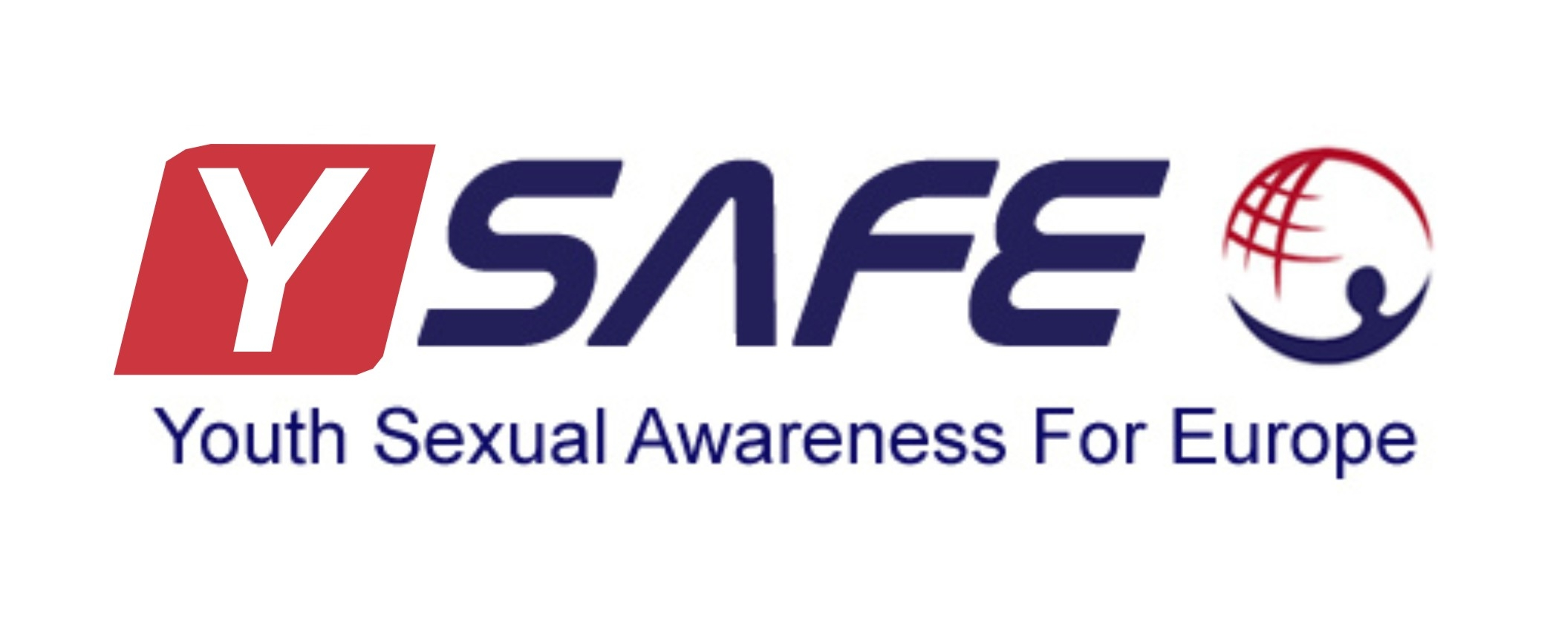
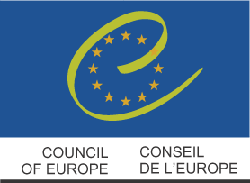
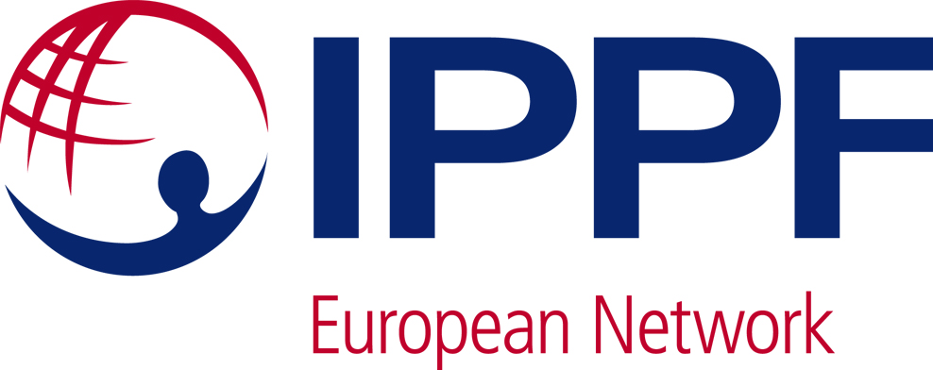

Call for participants YSAFE Study Session

A young volunteer can do anything -
Strengthening youth activism on Sexual and Reproductive Health and Rights

22-28 April 2013
European Youth Centre – Budapest

Deadline for application: 3rd of March 2013

Introduction
Youth Sexual Awareness for Europe (YSAFE) is inviting you to apply for the YSAFE Study Session that will take place in the European Youth Centre in Budapest from 22-28 April 2013 (travel days included). The Study Session is organized by the International Planned Parenthood Federation European Network (IPPF EN) and its youth network YSAFE, in cooperation with the Directorate of Democratic Citizenship and Participation – Youth Department of the Council of Europe (DDCP – YP).

Aim
The Study Session aims to strengthen youth activism and networking on comprehensive sexuality education within a human rights framework at regional and national level in Europe and Central Asia.

Objectives:
- Support young activists with knowledge, skills and tools to strengthen youth-led initiatives on sexual and reproductive health and rights and comprehensive sexuality education through human rights education and advocacy on national and regional level;
- Enable and empower youth activists to address comprehensive sexuality education through a human rights based approach;
- Provide a safe and open space for mapping challenges related to comprehensive sexuality education and identifying possible approaches in European and Central Asia context;
- Ensure space for networking between organizations engaged in comprehensive sexuality education for planning and implementing joint initiatives on national and regional level.

Participants profile
YSAFE is looking for 25 young volunteers from Europe and Central Asia that:

- Are under the age of 25;
- Are active in the YSAFE network, in an IPPF EN Member Association or in the World Organisation of the Scout Movement;
- Are committed to actively work before, during but also after the Study Session and have support from their national organisation in this process;
- Have experience in working for Sexual and Reproductive Health and Rights of young people;
- Preferably have experience in working towards access to Comprehensive Sexuality Education for young people;
- Preferably have experience in conducting advocacy activitities for young people’s Sexual and Reproductive Health and Rights.

Costs and reimbursements
Accommodation and meals are provided by the European Youth Centre at the expenses of the Youth Department of the Council of Europe. Travel expenses (the cheapest route possible) and visa costs are reimbursed by the Youth Department of the Council of Europe. Participants are expected to arrange their own travel (arrival on the 22nd of April, departure on the 28th of April) and will be reimbursed on the basis of the least expensive route between their place of residence and the European Youth Center in Budapest. In order to be reimbursed, participants will have to present originals of all the receipts/invoices for travel and visa costs as well as the tickets and boarding passes. Electronic tickets will only be considered as acceptable on proof of payment and on presentation of the boarding pass for the outward journey.

Participants or their national organisations are expected to pay a 50 euro participation fee for their participation in the Study Session. This fee will be deducted from their travel reimbursement. Insurance costs will not be reimbursed by the Youth Department of the Council of Europe. For participants active in IPPF EN Member Associations, insurance will be covered by IPPF EN insurance.

Reimbursement takes place in Euros at the end of the Study Session at the European Youth Center in Budapest. The participants should be present for the entire session. Participants attending less than 80% of the total duration of the session will not be reimbursed.

Visas for Hungary:
Citizens of the EU and EEA member states do not need a visa to enter Hungary.
Participants coming from non-member countries of the Council of Europe and the following countries: Armenia, Azerbaijan, Belarus, Georgia, Kosovo*, Moldova, Russian Federation, Turkey, Ukraine and participants from Estonia, Latvia and Lithuania having a non-national passport, must be in possession of a visa to enter Hungary. We suggest you contact the Hungarian Consulate service in your country sufficiently in advance to allow the participant to secure his/her visa and, if necessary, to contact other consular departments for transit visas. The Youth Department of the Council of Europe can offer visa support by providing written confirmation of the person’s expected participation in the activity if this is necessary to secure a visa. The cost of the visa is reimbursed upon presentation of a receipt. If the participant has to travel to get visa, the cost of the travel or agency fee can only be reimbursed if the participant has contacted the secretariat of the EYCB in advance and it has been approved. In any other cases the travel for the visa or the agency fee will not be reimbursed.

Application process
To apply, please complete the below application form and attach a support letter from your national/local organisation stating their support for your participation in the Study Session as well as how they will support you in the preparation and follow-up of the Study Session. Send the completed application form and the support letter to kdekkers@ippfen.org no later than the 3rd of March 2013. Selection of participants will be made in the week of 4-8 March and you will be informed accordingly.

We look forward receiving your application!

More information
Contact person: Karolien Dekkers, programme advisor IPPF EN
E-mail: kdekkers@ippfen.org
Phone: +32 (2) 250 09 50
Website: www.ysafe.net and www.ippfen.org

Application form

Personal information
Name
Surname
Full home address
Country
Gender
Date and place of birth
Email
Languages you speak | Mother Tongue
Languages you speak | Other Languages
Telephone number | Mobile
Telephone number | Home
Name of the national/local organisation you are active in
Full address of national/local organisation you are active in
Telephone number of national/local organisation you are active in
Fax number (if available)
Do you have any dietary requirements (vegetarian, no pork etc.)
Do you have any other special needs that you want us to take into account?
Visa information
Visa required to travel to Budapest, Hungary | Yes (please fill out all questions below)
Visa required to travel to Budapest, Hungary | No (please continue with the questions under the heading ‘motivation and background’)
Passport/ID card number
Place and date of issue passport/ID card
Expiry date of passport/ID card
Authority that issued the passport/ID card
Location of the embassy to be applied to
Motivation and experience
Why are you interested in participating in the YSAFE Study Session?

What is your experience in working for Sexual and Reproductive Health and Rights of young people? Please name at least 3 examples of activities that you were involved in 2012/2013.

What is your experience working towards access to Comprehensive Sexuality Education for young people?

Did you take part in any advocacy activities on Sexual and Reproductive Health and Rights or Comprehensive Sexuality Education for young people? If yes, can you please explain the activity and your role in the activity?

Can you commit yourself to work before, during and after the Study Session (by implementing the action plan you will develop during the Study Session)?

What kind of follow-up activities are you thinking about/do you want to develop in cooperation with your national/local organisation?

Do you have anything else that you would like to share in support of your application?

Youth Sexual Awareness For Europe (YSAFE) is a youth network on Sexual and Reproductive Health and Rights. It is a project of the IPPF European Network geared at empowering youth participation in decision making and implementation at both the Member Association and Regional levels. For more information see www.ysafe.net.
The International Planned Parenthood Federation European Network (IPPF EN) is one of 6 regions of the International Planned Parenthood Federation which was founded in 1952 and is the strongest global voice safeguarding sexual and reproductive health and rights (SRHR) for people everywhere. IPPF EN includes 41 membership-based associations throughout Europe and Central Asia, as well as the Regional Office in Brussels, Belgium. For more information see www.ippfen.org.
If there is no possibility for the participant or the national organisation to pay the participation fee, please contact kdekkers@ippfen.org.

