To: Chief Executives, National Directors, Secretaries General of National Scout Organisations and WAGGGS Member Organisations

From: Ann Brookes, Acting Regional Director, Europe Region WAGGGS
David McKee, Regional Director, World Scout Bureau - European Regional Office

7th Meeting for Chief Executives, National Directors, and Secretaries General

Joint Circular 31 July 2012

Dear Friends

We are pleased to provide information on the next Meeting for Chief Executives, National Directors, Secretaries General or equivalent positions. This will be the seventh time that this meeting has been held.

As proposed at the last meeting, we will be hosted by rdp – Ring deutscher Pfadfinderinnen- und Pfadfinderverbände (Germany) from 13 to 14 November 2012 at andel’s Hotel, Berlin, the venue of the European Conferences next year in August.

As before, the aim of the meeting is to provide an opportunity for senior staff in Associations to come together and share experiences, challenges, best practices and questions. It is not a training event. The target audience is the senior professional leadership of Associations at the level of Chief Executive or equivalent and their immediate deputies.

The Regional Directors will facilitate this meeting, but it requires the active engagement of all participants.

At the previous meeting some suggestions for the programme were:
- Funding, foundations and corporate social responsibility
- Using the development potential of recession for growth
- Development of leadership in associations

Please complete the programme section of the registration form to give us an idea of your particular interests and to indicate sessions or topics that you would like to offer.

Practical Details
The venue is andel’s Hotel Berlin, Landsberger Allee 106, D 10369 Berlin (see also: www.andelshotel.com). Directions on how to reach the hotel from the various Berlin airports will be provided in the Joining Instructions, which will be issued closer to the event. A suburban metro station is located about 50 metres from the hotel.

The participation fee is EUR 170 and this covers accommodation (1 night), lunches, dinner and refreshments during the meeting. This should be paid in cash at the meeting. Additional nights accommodation is EUR 89 per night.

The meeting will begin at 10.30 am on Tuesday, 13 November 2012, and end at 14.00 pm on Wednesday, 14 November 2012.

Please note that no travel grants are directly available for this event but you may contact your appropriate Regional Office to discuss other possibilities.

If you require a visa, please provide all the necessary information on the booking form. On completion of the registration form, our hosts will issue a letter of invitation.

The meeting will be conducted in English. On past events participants have facilitated support for other languages.

How to apply
Please complete the attached application form and return it no later than Monday, 13 October 2012 to the WOSM – European Regional Office. The meeting will go ahead if there are at least 10 participants. Please do not book travel until you have received confirmation that the event will proceed.

The registration form has space to identify ways that participants can be involved in the programme of the event. Please complete this section carefully as well.

We are looking forward to welcoming you to the andel’s Hotel, Berlin and to a productive and reflective time together.

Best wishes.

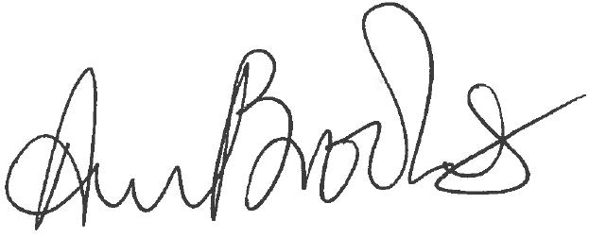
Ann Brookes
Acting Regional Director – Europe Region WAGGGS

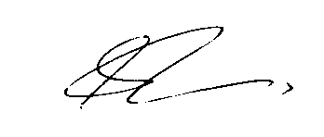
David McKee
Regional Director – WOSM European Region

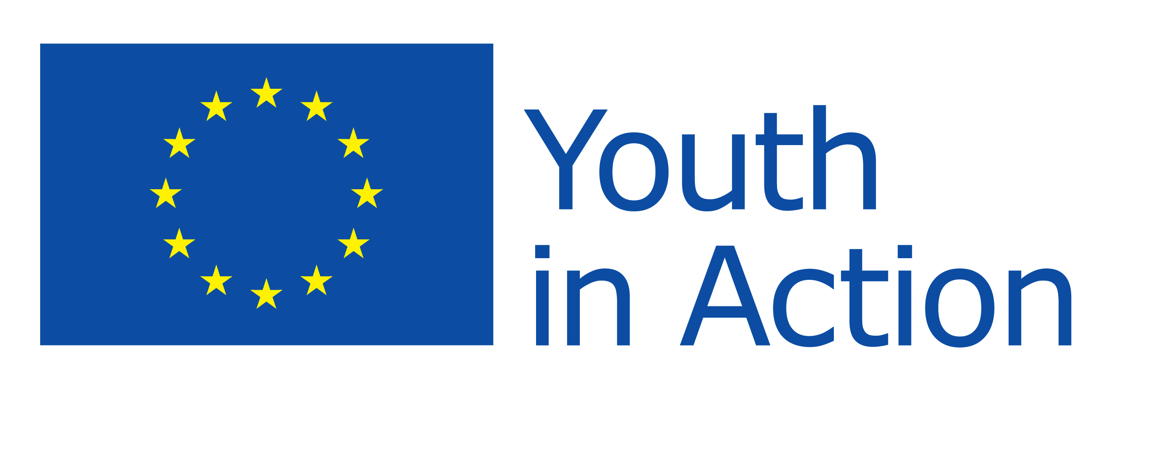
This project has been funded with support from the European Commission.

