Application Form
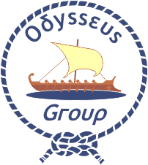
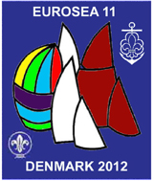
Eurosea 11

Copenhagen, Denmark, 19-23 September 2012

Please complete this form in capital letters and return by 15 June 2012 to:
European Scout Office, Rue Henri Christiné 5, Box 327, CH - 1211 Geneva 4, Switzerland
Tel: (+41.22) 705 11 00 • Fax: (+41.22) 705 11 09 • email: europe@scout.org

First name and family name |  |  | Gender  Male  Female 
Date and place of birth |  | Nationality
Email | Telephone |  | Fax
Association

Position in the Association

Please indicate your level of English proficiency
English Very Good  Good  Can Manage  Poor  None 

Do you have any dietary or other special requirements? If so, please specify

Have you ever participated in a European Scout event?  Yes  No  |  | Do you need an official invitation to obtain a visa?  Yes  No 
Date and Signature of International Commissioner

For those needing a visa
Passport number |  | Nationality
Date of issue | Place of issue |  | Date of expiry
Address

I agree that photos taken at the seminar can be used and published only for Scouting purposes.
Since the event will be held in English, participants must be able to commutate well in English.

